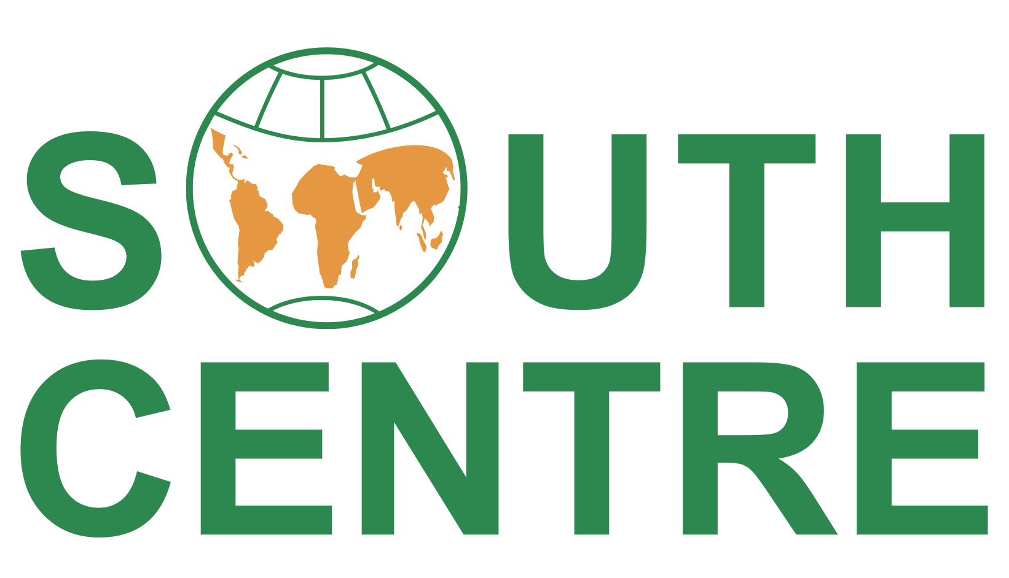

Application Form: Financial Support for Civil Society Advocacy during World AMR Awareness Week (WAAW) 2025

Please complete this application form and send it to Ms. Caroline Ngome Eneme at ngomeeneme@southcentre.int by 20 September 2025. In case you need more space to provide information on your project, please attach it in a separate document. Any questions about this call can also be sent to this email address. The selection result will be announced by 10 October 2025.

- Name of the institution, main contact person and email

- What is the focus of the institution’s work on AMR?

- Please provide an example of an effective past campaign on AMR

- What will be the focus of your campaign during WAAW?
Please describe the activity or activities that this funding will support.

- How will you measure the success/impact of your campaign? i.e., the scope of reach to the target audience?

- Have you requested and/or received previous funding support from the South Centre?

- Amount of funding requested (maximum 2000 USD)

- How will the funding be used to support your campaign during WAAW? Please provide an estimate budget breakdown.

- Would this be the sole source of funding for the campaign or will it be co-funding?

- Please feel free to provide any additional information you may consider relevant or attach complementary information

